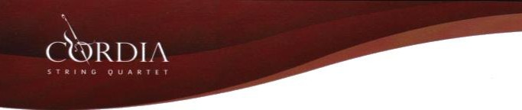

Phone: 79553569
E-mail: cordiaquartet@gmail.com

Music | Musician | Time
Before the entrance of the Bride:

(could be used for the entrance of the Mother of the Bride and the bridesmaids.
Arioso | Bach
Canon in D | Pachelbel
Entrance of the Queen of Sheeba | Handel
Hornpipe in D | Handel
Rondeau | Mouret
Nearer my God to thee | Traditional
Te Deum | Charpentier
Trumpet Tune | Purcell
Trumpet Voluntary | Clarke
Entrance of the Bride
Ave Maria | Bach*
Ave Maria | Caccini*
Ave Maria | Schubert*
Here comes the bride | Wagner
Alleluia
Alleluia | Mozart*
Halleluia | Cohen*
Background music during marriage rite
Nearer my God to thee | Traditional
Ode to Joy | Beethoven | This could start as soft  music and the erupt for the applause
The Prayer | Sagner/Foster
The Rose | Bette Midler
You raise me up | Josh Groban

©Cordia quartet

After marriage rite:
Hallelujah | Handel
Ode to Joy | Beethoven
Trumpet Tune | Purcell
Trumpet Voluntary | Clarke
Offertory
Air on G string | Bach
Amazing Grace | Folk Hym
Ave Verum | Jenkins
Ave Verum | Mozart*
Laudate Dominum | Mozart*
Largo | Handel
Our Father
The Lord’s Prayer | From the Vagabond King
Peace giving
Evenu Shalom | Jewish Theme
Greensleves
Holy Communion
Amazing Grace | Traditional
Anima Christi | Frisina
Ave Verum | Jenkins*
Ave verum | Mozart*
Be thou my vision | Iris Tune
Gabriel’s oboe | Theme from ‘The Mission’
Guide me thou Great Redeemer | Traditional
Here I am Lord | D.Schitte
It-Talba | Ġensna
Jesu Joy of men’s desiring | Bach
La Novia | Pietro Mogol
Laudate Dominum | Mozart*
Meditation | Massenet
Nearer my God to thee | Traditional
Panis Angelicus | Cesar Frank
Pour down my love | Gavin Byrne
The Prayer | Sagner/Foster
Signing of Register
A time for us | Romeo and Juliet
Air on G string | Bach
As I kneel before you | Marie Parkinson
Chariots of Fire | Vangelis
From this moment | Shania Twain
Updated January 2017

©Cordia quartet

